**Jenkins Automation for Deploying Updated index.html from multiple Environments**

Create 3 repo in git and index file in every repo

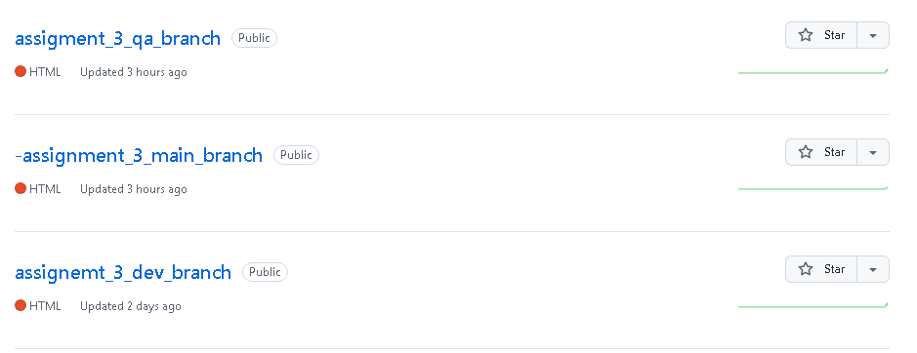

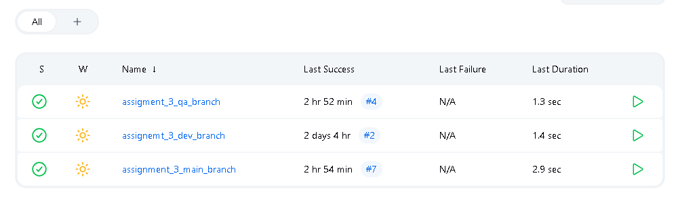

Create job for each branch

Put this syntax in shell

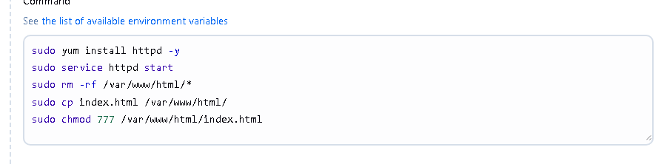

Poll SCM or GitHub hook trigger so as you update any of repo then job will get built and updated index file will run.